Curriculum Vitae

Personal Data___________________________________

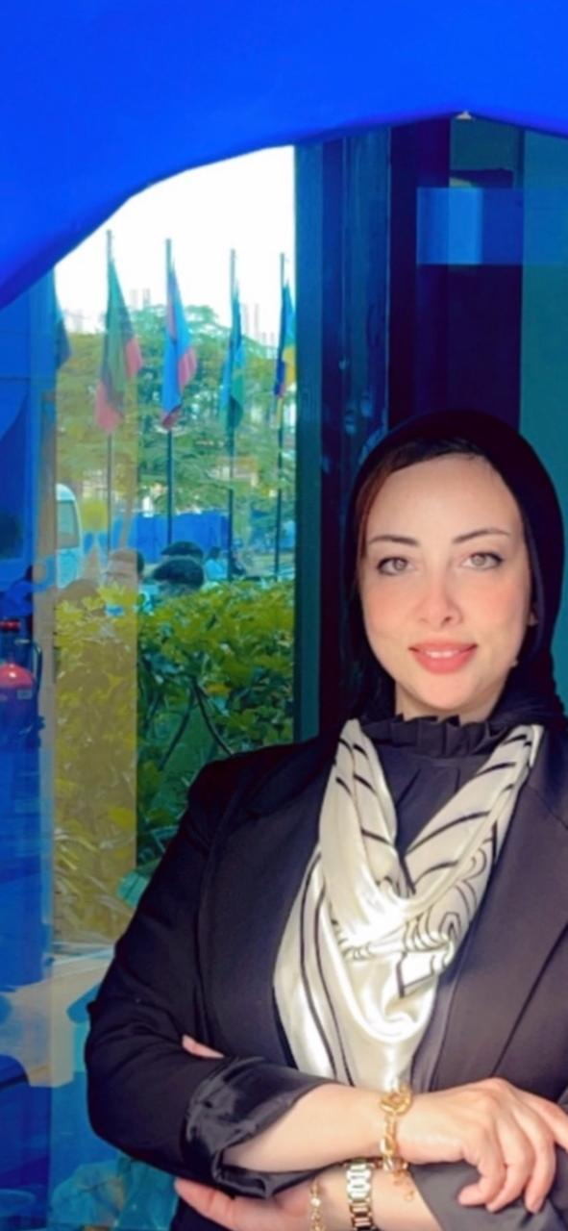
Name: Marwa Ahmed Mostafa Gad Allah
Date of Birth: 5th July, 1983
Nationality: Egyptian
Mobile: 01005168909
Address: Egypt , Giza , 6th of October , 4th district
e-mail: Marwa0gadallah@yahoo.com

Career Objective:
To join an excellent work environment, earn a job that provides me job satisfaction and self-development and help to achieve my personal as well as organization goals.

Education______________________________________

September 2004 B.A., Department of Press &Media, Faculty of Arts, Shebin El Kom, Menofia University.
July 2016-2017 ‎Pre-Master's in journalism, faculty of arts, Menofia university.
March 2020
MASTERS DEGREES IN COMMUNICATION AND MEDIA (THE ROLE OF SOCIAL NETWORKING SITES IN SHAPING THE KNOWLEDGE AND ATTITUDES OF EGYPTIAN WOMEN TOWARDS THEIR ISSUES) .
May 2023
PHD IN MEDIA THE ROLE OF SOCIAL NETWORKING SITES IN HEALTH AWARENESS OF THE CORONA VIRUS DEPARTMENTOF PRESS& MEDIA, FACULTY OF ARTS, MANSOURA UNIVERSITY.
Department Courses: include journalistic arts, visible communication, audible communication, public relation, media and educational media.
Accumulative Grade: Good
Graduation Project: Make journal and journalistic interview at Menoufia University, with grade "Excellent".

Training Experience______________________________
Oct. 2003 to Apr. 2003 | Journalist in Al-Ahram Journal, Cairo.
Jan. 2004 to Feb. 2004 | PR member at Menoufia University.
Oct. 2005 to Jun. 2007  Sep. 2011 to Sep. 2016  Sep.2016 to Sep. 2018  Sep.2018 to Sep. 2019 | Press, Media and Communication skills trainer at Menoufia University.  Teacher of press and educational media at American language schools, Menoufia.  head of media department at American language schools.  Head of press & media department at smart language schools, Benha.
Sep. 2019 2020 DIRECTOR Of PUBLIC RELATIONS (DELTA TECHNOLOGICAL UNIVERSITY)
Sep.2020: Till now
Assistant Teacher at the Arab academy for science, technology & maritime transport,cairo college of language and communication AAST-MEDIA- SMART VILLAGE
Languages _____________________________________
Arabic: | Fluent (Mother Tongue)
English: | Very Good

Technical Courses________________________________
Micro-Controllers “INTEL ATMEL8051”: | Good.
MATLAB Basics: | Good.

Computer Skills_________________________________
Microsoft Office Package: | Excellent.  (Word: Excellent, Access: Excellent, PowerPoint: Excellent,Excel: Very Good, Publisher: Good).

Soft Skills______________________________________
1. Easily establish rapport with managers and co-workers.
2. Ability to work individually and within a team.
3. Excellent presentation &communication skills.
4. Proven ability to prioritize and complete multiple tasks.
5. Highly organized and self-motivated.
6. Ability to work under pressure.
7. Adapts easily with various cultures and multi-nationalities.
8. Ability to manage a team and make business strategic plan.
HR Trainings____________________________________

Presentation Skills. | Leadership.
Making Interview. | Strategic Planning.
Communication Skills. | Time Management.
Certificates of Appreciation_______________________
- supporting students to reach the highest level of academic performance and activities.
- best live broadcasting.
- educational press.
- Media interview
- Educational media.
- press events.
- party planning.

Hobbies________________________________________
Public Relation, Reading, Teaching, Playing Music.

